**WORKSHEET 5**

**Student Name:** Vivek Kumar **UID:** 21BCS8129

**DOMAIN CAMP:** 16-01-2023 to 28-01-2023 **Section/Group:** DWWC-77

**Subject Name:** IT Skills (DSA)

# Question 1. PRODUCT OF THE LAST K NUMBERS

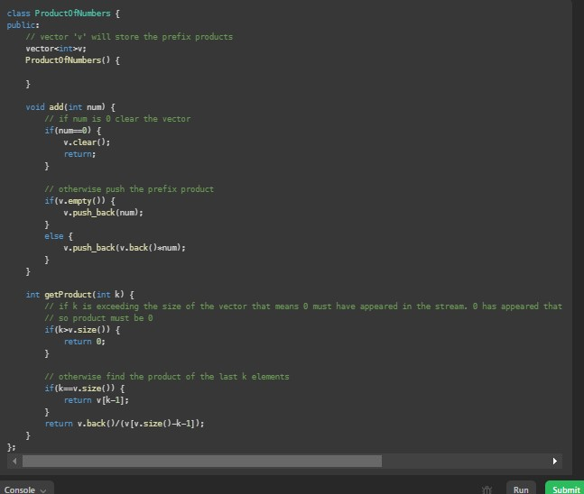

# Question 2. IMPLEMENT QUEUE USING STACKS

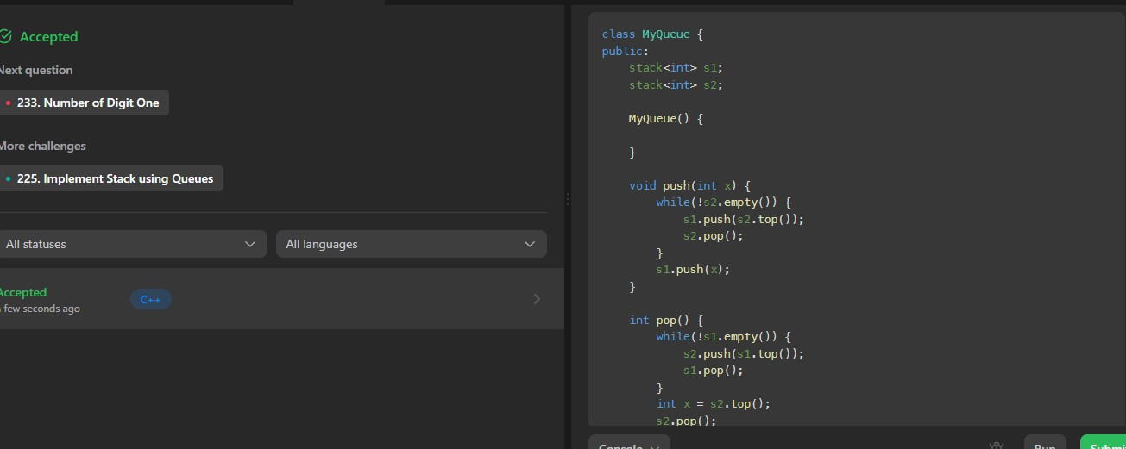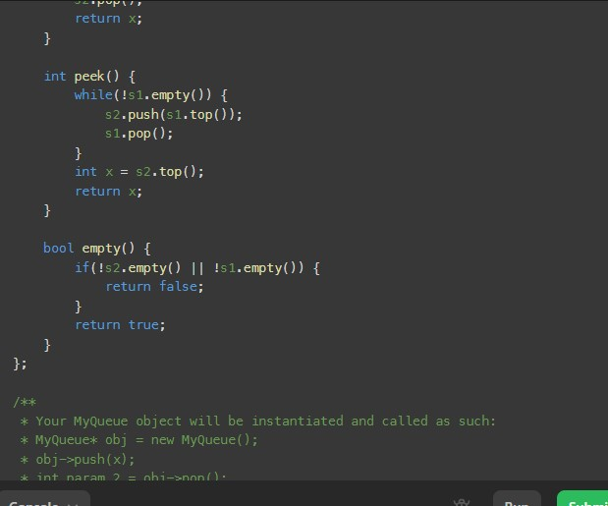

# Question 3. DESIGN CIRCULAR QUEUE

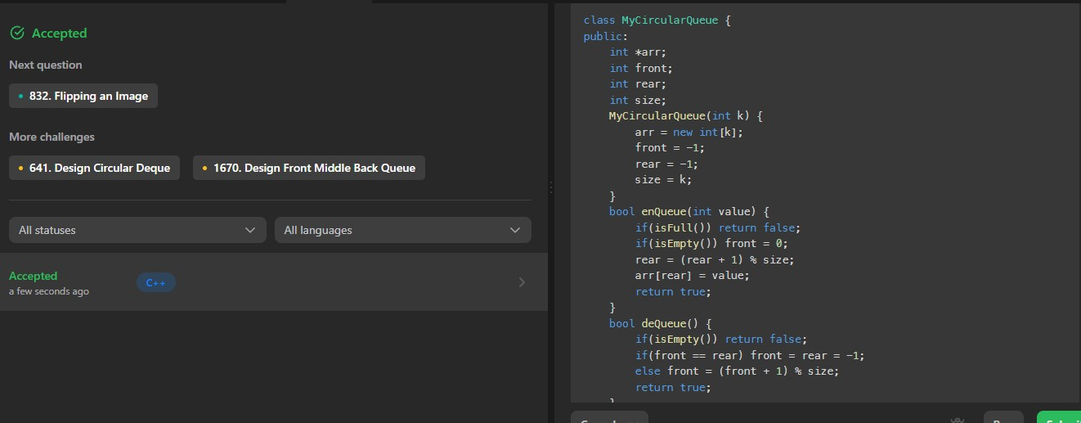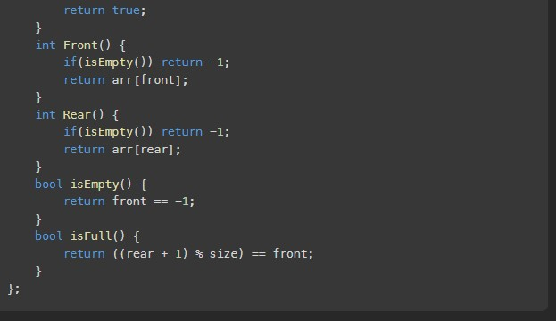

# Question 4. DESIGN FRONT MIDDLE BACK QUEUE

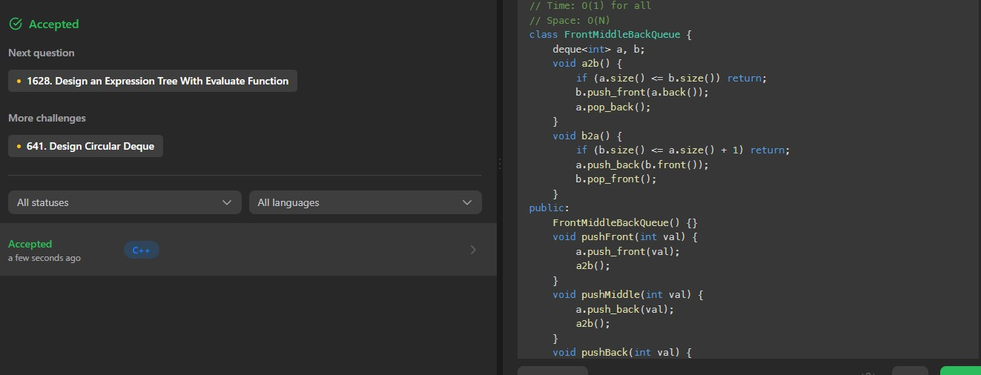

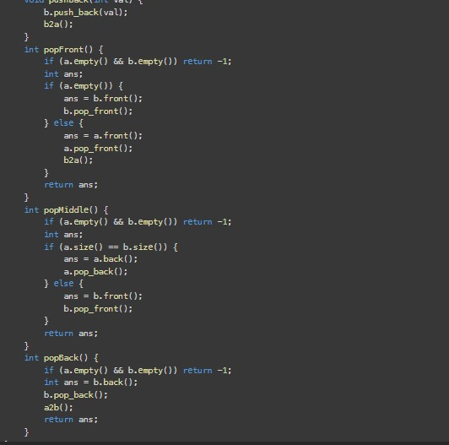

# Question 5. BOOK EXERCISES

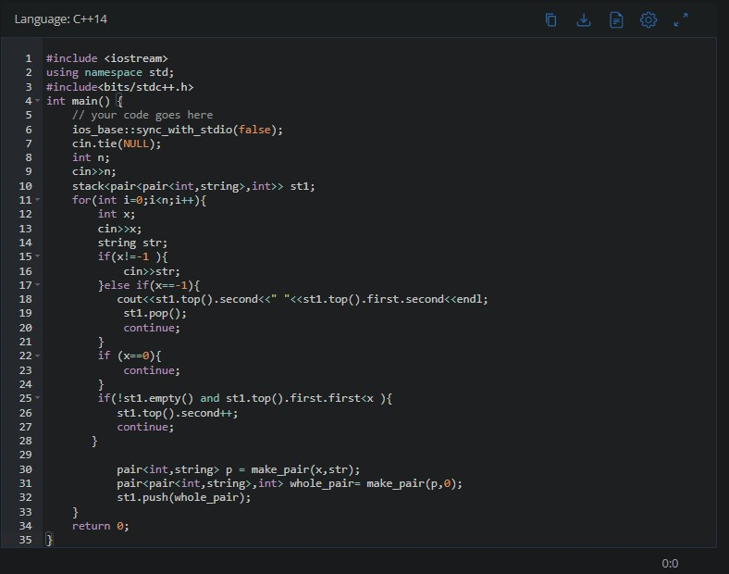

**SOLUTION:**

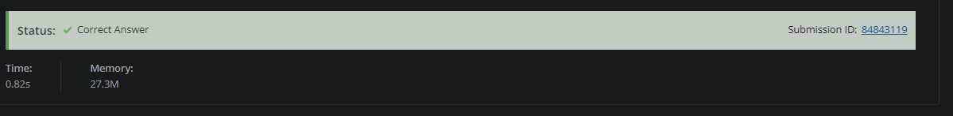

# Question 6. SUBARRAY SUM

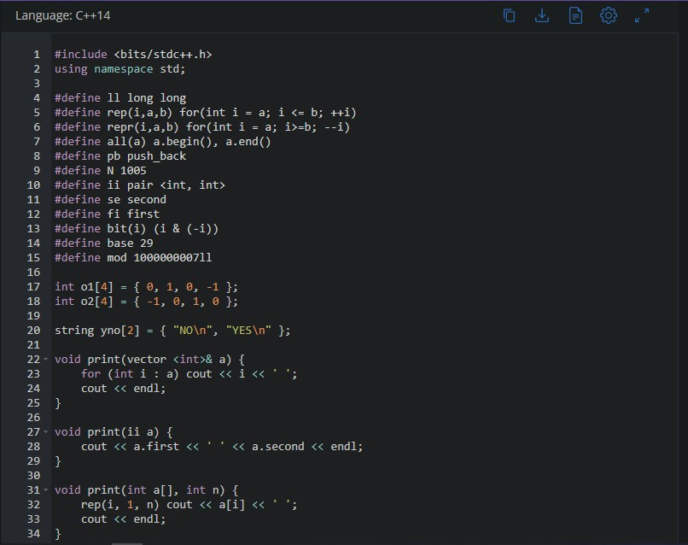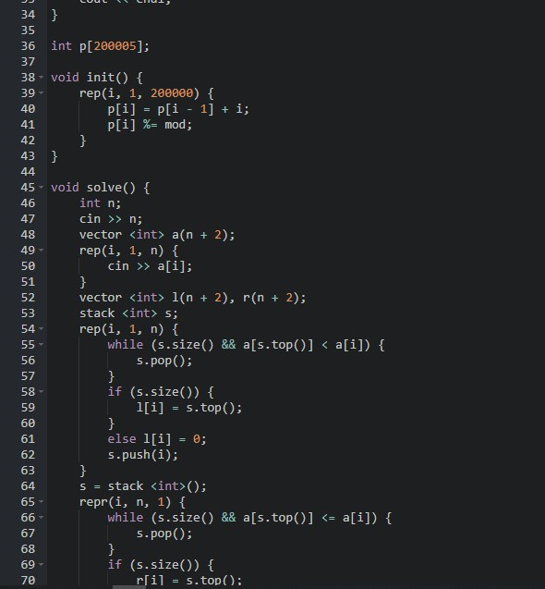

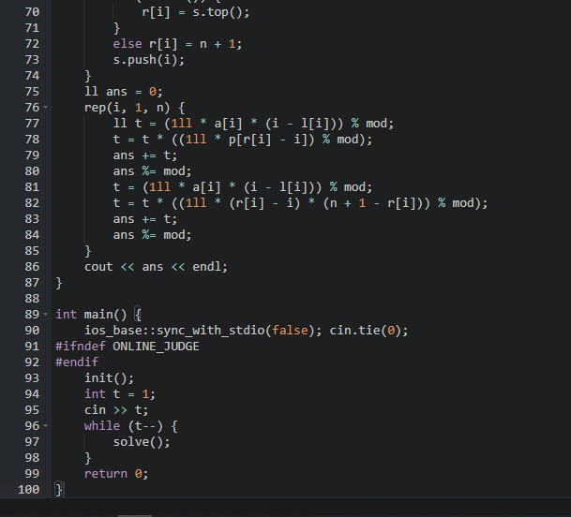

**SOLUTION:**

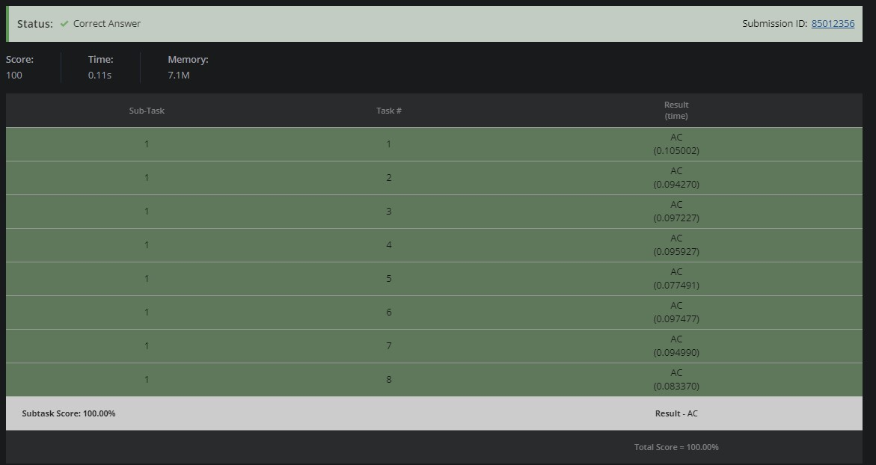

# Question 7. ABSOLUTE MIN MAX

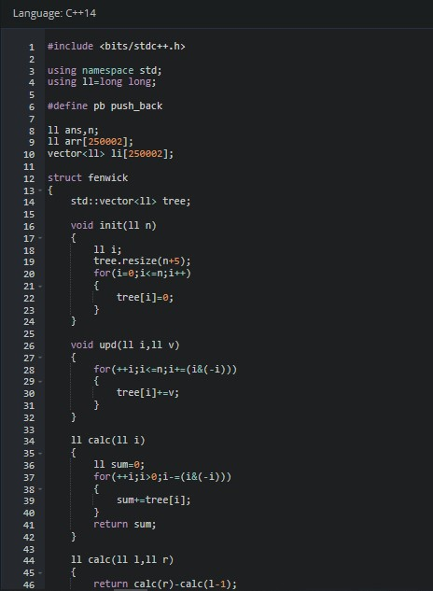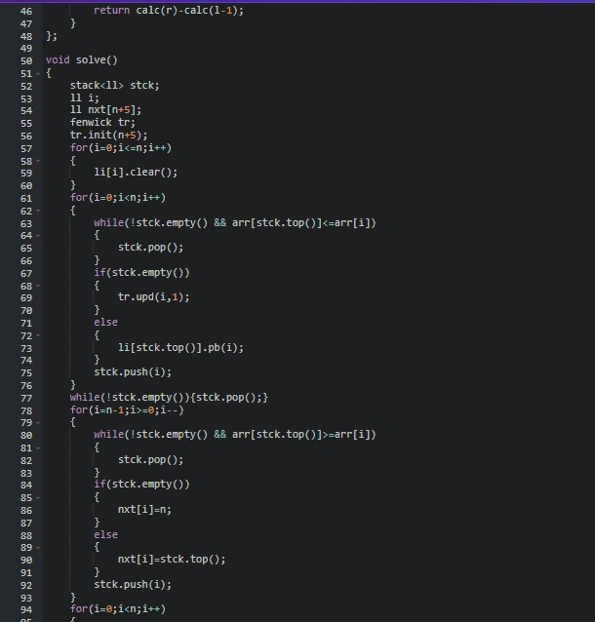

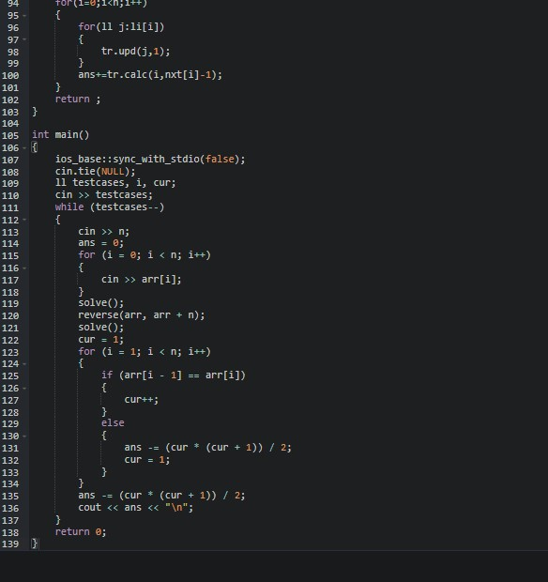

**SOLUTION:**

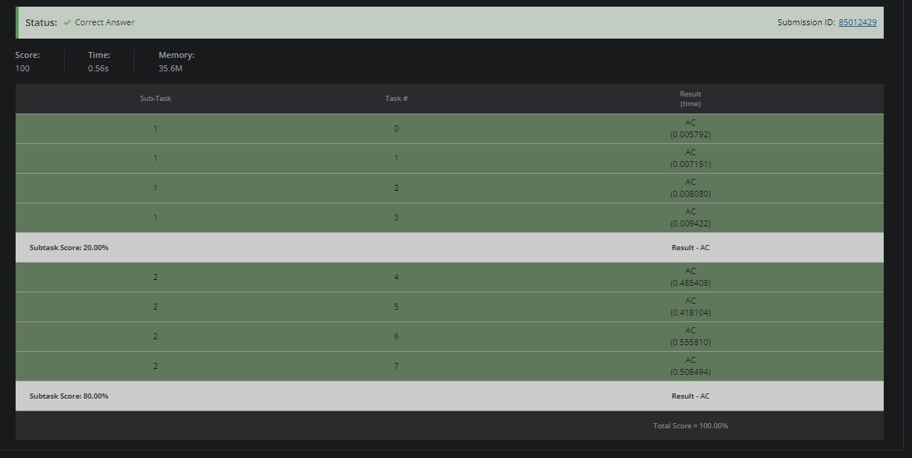

# Question 8. WEAK IN THE MIDDLE

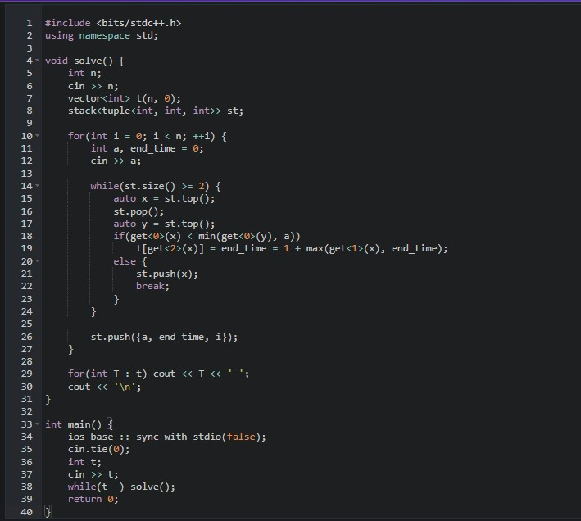

**SOLUTION:**

